Problem: Find four equations of graphs which form a square

I once had a Year 7 Springboard group who I would let play noughts and crosses if they could give me four equations of graphs which would make the grid. You don’t need to play noughts and crosses, and the problem can quickly lead to much deeper Mathematics. Stage 3 can lead students into discovering that product of gradients of perpendicular lines is always -1.

Stage 1

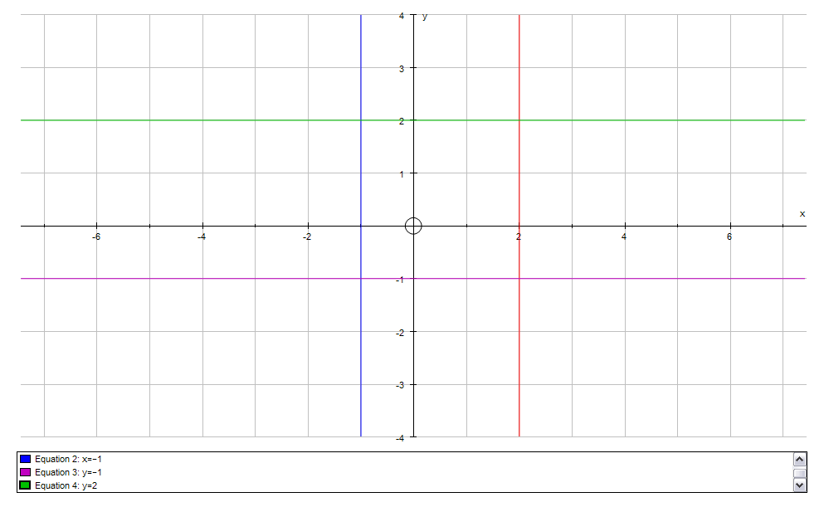

Stage 2

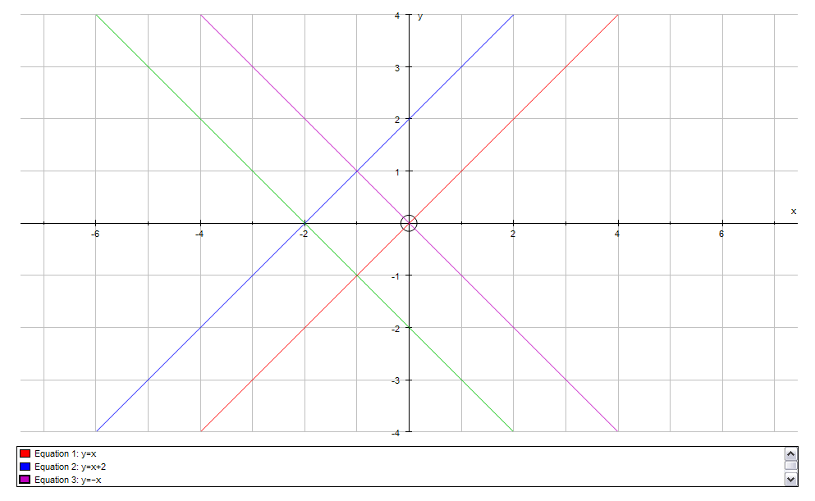

Stage 3

